**webapi接口**

**开发：任务 #2914**

http://projects.signalfire.cn/issues/2914

### 创建leadership的接口数据

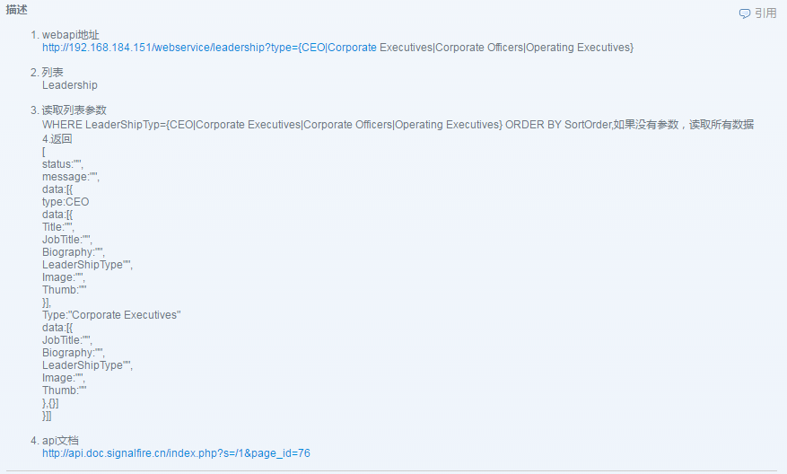

域名：[**http://192.168.184.151**](http://192.168.184.151/webservice/leadership?type=%7BCEO%7CCorporate)（服务器）

**/webservice** ：IIS网站下站点(发布生成的DLL存放的位置)

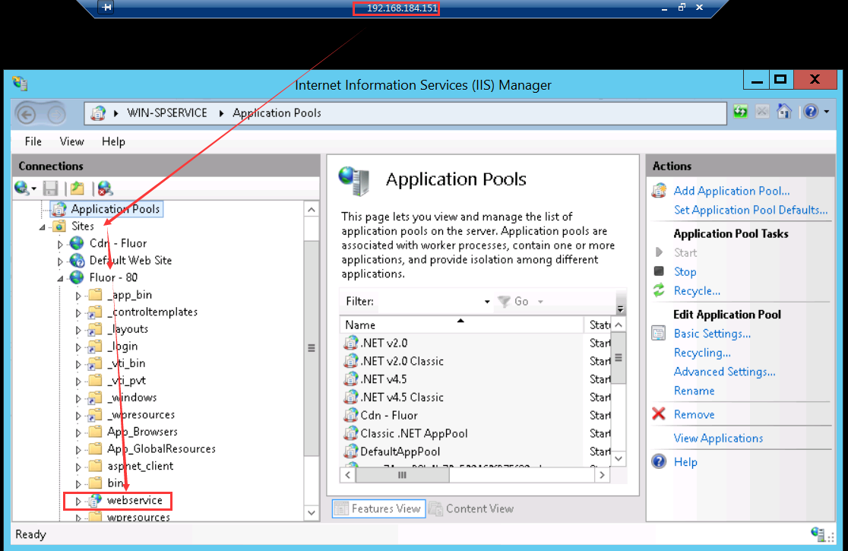

通过Vs生成的DLL放在webservice 应用程序(application) Bin文件下

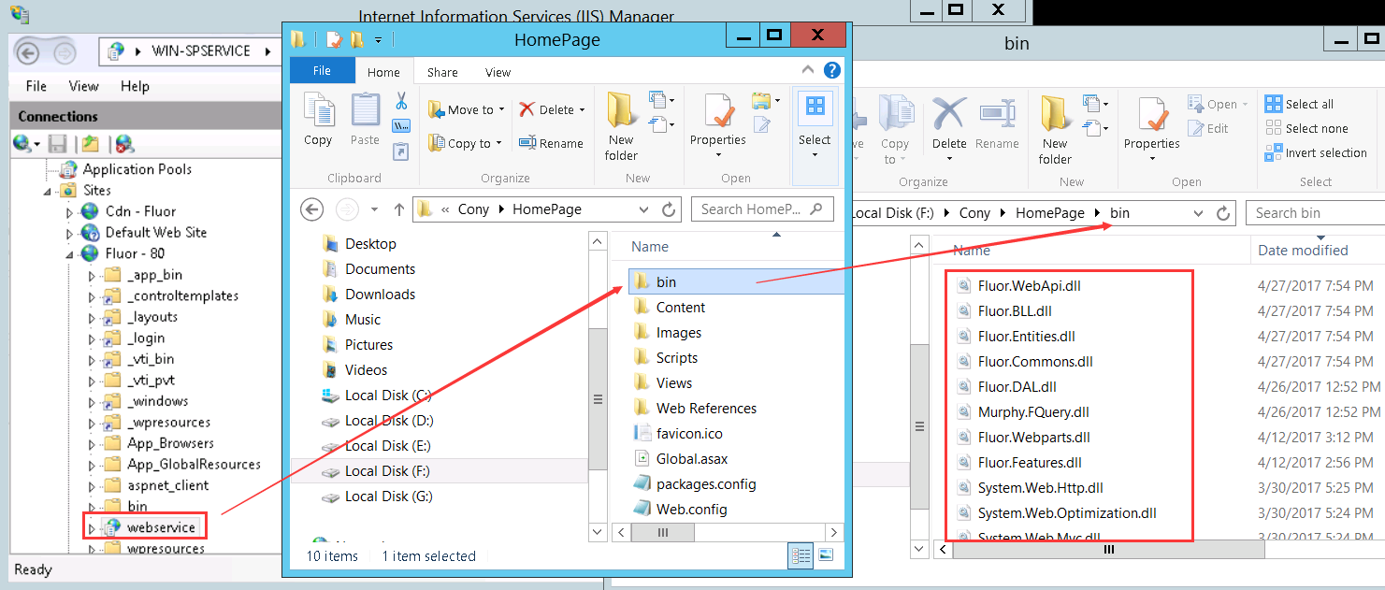

SVN：https://svn.signalfire.net.cn/svn/murphy/Fluor_2017_Relaunch/Rebuild_Flour.com

地址获取项目

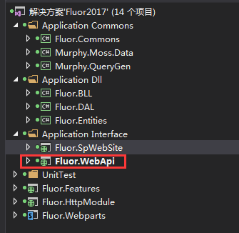

**/Leadership 根据这个路径可以建立一个Leadership 控制器**

**?**[**type={CEO|Corporate**](http://192.168.184.151/webservice/leadership?type=%7BCEO%7CCorporate)**Executives|Corporate Officers|Operating Executives}**

**根据参数**

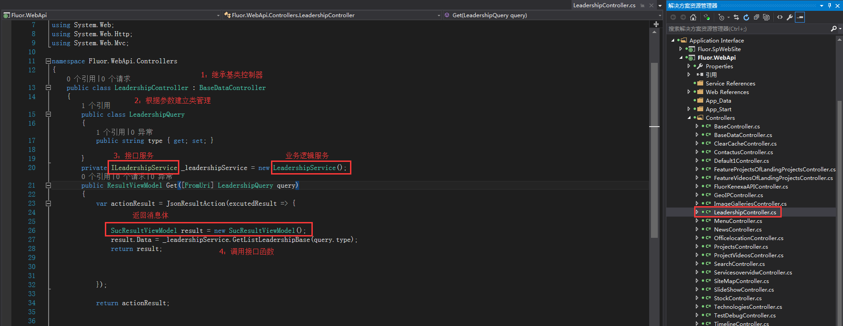

**public class LeadershipController : BaseDataController**

**{**

**public class LeadershipQuery**

**{**

**public string type { get; set; }**

**}**

**private ILeadershipService _leadershipService = new LeadershipService();**

**public ResultViewModel Get([FromUri] LeadershipQuery query)**

**{**

**var actionResult = JsonResultAction(excutedResult => {**

**SucResultViewModel result = new SucResultViewModel();**

**result.Data = _leadershipService.GetListLeadershipBase(query.type);**

**return result;**

**});**

**return actionResult;**

**}**

**}**

**再在Fluor.BLL的Interface建立接口** ILeadershipService

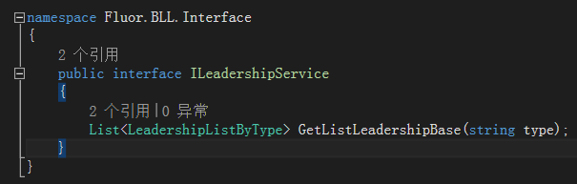

**public interface ILeadershipService**

**{**

**List<LeadershipListByType> GetListLeadershipBase(string type);**

**}**

**再在Fluor.BLL建立一个**LeadershipService

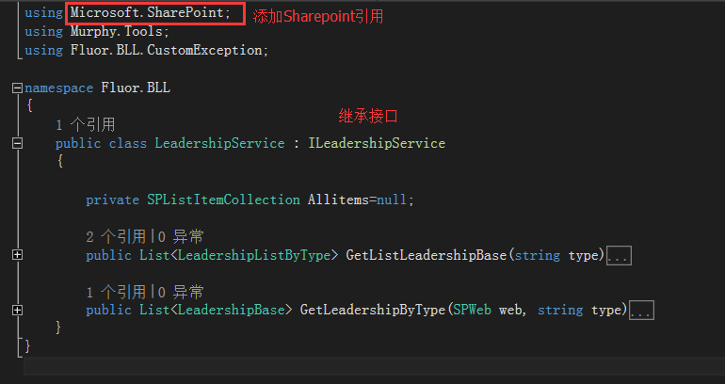

**格局返回数据，需要建立实体类**

